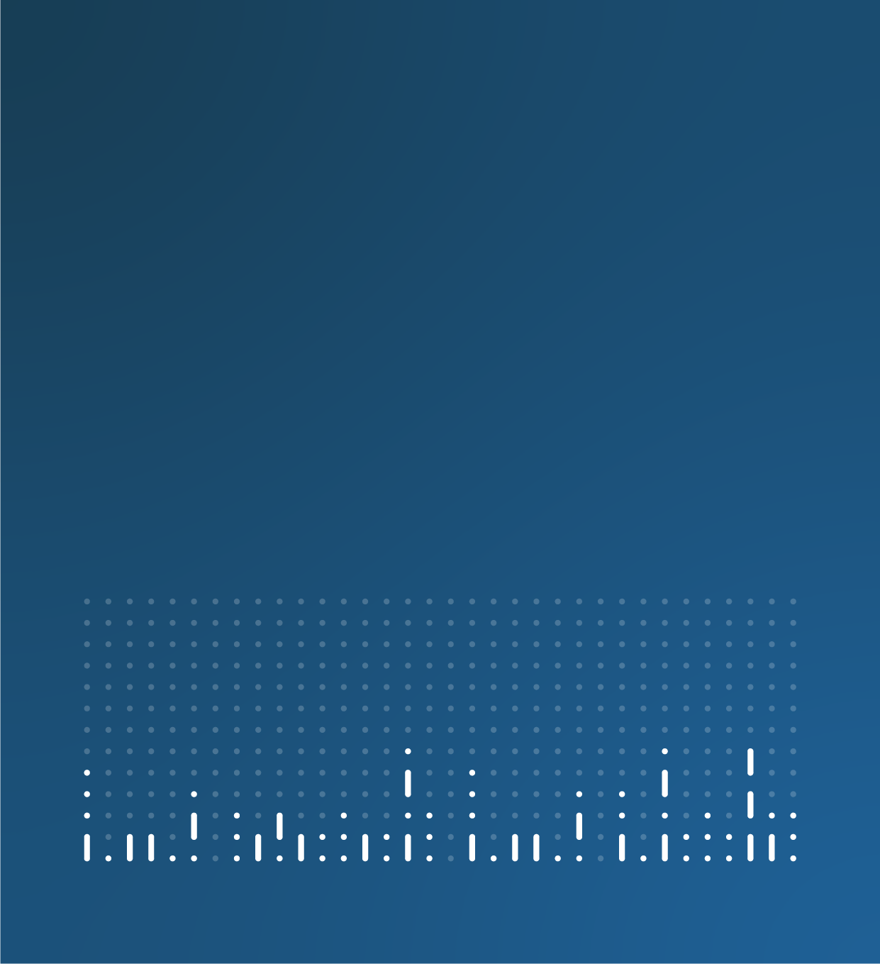

Household Cost Indices user needs engagement updates
Office for National Statistics

Last updated: 8 May 2026



Contents
8 May 2026 update 2
17 December 2025 update 4

8 May 2026 update
Thank you to everyone who has provided feedback on the Household Costs Indices.
We asked
We are asking users of the HCIs to share how they use them, and where improvements could be made, such as to their presentation, frequency or granularity. The feedback from users will be used to inform our publication strategy and help us refine the HCIs to better serve users, especially in the context of ongoing cost-of-living pressures.
You said
As of 8 May 2026, we have received 19 responses from a variety of users. The below table provides an overview of the number of responses that have been received per sector.
Sector | Count of responses
I am responding out of personal interest | 9
Arm’s length body | 0
Business or social enterprise | 4
Devolved government | 0
Education – higher education | 1
Education – schools or further education | 0
International organisation | 1
Local government | 2
Media | 0
National government department | 2
Public body or service | 0
Research and development or think tank | 0
Voluntary | 0
Other | 0

The majority of respondents shared that they were content with the current communication for the HCIs.
Users shared that they valued granularity and data being available at smaller geographies, as well as a demand for monthly data.
We did
Next steps
We would like to thank everyone who has taken part in this user engagement activity so far. Your feedback is being actively taken into consideration, supporting work to improve methodology and ensure HCIs meet user needs as much as possible as we work towards accreditation as an official statistic.
The engagement remains open, so please continue to share your views.

17 December 2025 update
Thank you to everyone who has provided feedback on the Household Costs Indices (HCIs). Your responses are helping us shape future improvements to the indices, including how they are presented and published. We are currently reviewing all input and will share updates on next steps when they are available. The engagement remains open, so please continue to share your views.

