

UK Standard Industrial Classification Revision – Update

8 May 2025



Contents

About this consultation 2

Guiding principles for UK Revision following the consultation 3

Next steps 6

Appendix 7

How statistical units are classified 8

The structure of the new SIC classification framework 11

# About this consultation

The Office for National Statistics (ONS) consulted from 31 October 2023 to 23 January 2024 on the UK’s adoption of industrial classification of economic activity.

We asked users of the [UK Standard Industrial Classification](https://www.ons.gov.uk/methodology/classificationsandstandards/ukstandardindustrialclassificationofeconomicactivities/uksic2007) (SIC) to consider:

* which international classification framework the UK should adopt following the [International Standard Industrial Classification of All Economic Activities](https://unstats.un.org/unsd/classifications/Econ/ISIC.cshtml) (ISIC) and the [Statistical Classification of Economic Activities in the European Community](https://ec.europa.eu/eurostat/web/nace) (NACE) frameworks being revised
* to what level of alignment the UK should adopt the ISIC and/or NACE frameworks
* whether additional UK disaggregation to five-digit subclass level should continue
* how different options could impact current users of the classification framework

Following the consultation, the [National Statistician's Committee for Advice on Standards for Economic Statistics](https://uksa.statisticsauthority.gov.uk/the-authority-board/committees/national-statisticians-advisory-committees-and-panels/national-statisticians-committee-for-advice-on-standards-for-economic-statistics-nscase/) (NSCASE) discussed the responses to the consultation and the next steps. The UK SIC consultation webpage includes a count of respondents by sector, alongside five common concerns raised in the free-text response field.

The minutes from the NSCASE discussions are available on the UK Statistics Authority website for [April 2024](https://uksa.statisticsauthority.gov.uk/publication/national-statisticians-committee-for-advice-on-standards-for-economic-statistics-minutes-22-april-2024/#pid-minutes) and [July 2024](https://uksa.statisticsauthority.gov.uk/publication/national-statisticians-committee-for-advice-on-standards-for-economic-statistics-minutes-29-july-2024/#pid-minutes).

The NSCASE decision was broadly that the UK should maintain comparability with the ISIC and NACE frameworks, but that there should be flexibility at the four-digit and five-digit levels. This would ensure that a UK framework properly reflected the UK economy.

We are now in a ‘revision’ process where we expect to conclude the design of the UK framework by March 2026. We will begin engaging with relevant stakeholders to ensure we are accurately designing a UK framework that best reflects the needs of our users. We will update this page as this process develops.

## Guiding principles for UK Revision following the consultation

1. International comparability must be maintained

A key priority for respondents is international comparability. NACE is a useful classification framework as it is more granular than ISIC, but it retains comparability with ISIC as its categories are identical to or subsets of ISIC categories.

In a similar sense, SIC categories at all levels must always be the same as NACE categories or be subsets of NACE categories. This allows full comparability with NACE categories and ISIC categories.

1. Five-digit subclasses should be retained in UK SIC

Maintaining the existence of five-digit subclasses is a clear priority for respondents, allowing the UK economy to be more accurately described and measured.

1. NACE will be the starting point for creating new UK SIC categories, but there are benefits to the UK taking advantage of its new flexibility, while maintaining international comparability

As international comparability is a key priority for respondents, the most helpful starting point for creating UK SIC categories is NACE.

However, there are three clear beneficial reasons why SIC users may make use of the new flexibility the UK has when creating SIC categories, outlined as follows:

1. A limited number of ISIC divisions could be perceived as better describing the UK economy than NACE divisions

An ISIC division is possibly more detailed for suitably describing the UK’s economy than the equivalent division in NACE. For example, division 64 (financial service activities) has more granular categories in ISIC than in NACE, and in a country like the UK with a developed financial sector, some SIC users may find this additional granularity is helpful.

ii. Statistical balance must be considered when creating a classification framework

Another benefit to using the flexibility afforded to the UK is that it will allow international best practice to be followed. The [United Nations Best Practice Guidelines for Developing International Statistical Classifications](https://unstats.un.org/unsd/classifications/bestpractices/Best_practice_Nov_2013.pdf) requires ‘statistical balance’ to be considered.

A balanced statistical classification should have a hierarchy of categories, where each level is similar in population size. This statistical balance allows a classification to be used more effectively by users.

NACE takes into account the structure of European Statistical System (ESS) economies, but that does not mean that a statistically balanced framework for the UK would look identical to its ESS equivalent.

Therefore, it is possible that creating subsets of NACE four-digit classes would result in UK SIC being no less comparable to NACE but more statistically balanced from a UK perspective.

iii. The structure of a classification framework can lead to the same statistical unit being classified to different categories

The process for classifying some statistical units results in different outcomes depending on the structure of the classification framework used. This means that the quality of the statistics being produced can be enhanced by prioritising some category splits over others.

This also means that, in limited circumstances, there may be a benefit to creating more SIC classes that are subsets of NACE classes than creating five-digit SIC subclasses beneath four-digit NACE classes.

4. Changes to provide more granularity in services industries and to reflect the digital economy should be prioritised

A [UK Statistics Assembly](https://uksa.statisticsauthority.gov.uk/uk-statistics-assembly-2025/) was held in January 2025, jointly organised by the UK Statistics Authority and the Royal Statistical Society. Assembly attendees provided views that:

* the current SIC is not representative of the current economy and is out of date, particularly regarding service industries
* the digital economy is not represented adequately in the product or industry guidance
* collaboration between the statistical system and business is central to improvements being made
* the UK needs a classifications framework that is consistent over time and internationally coherent

1. A review of the product guidance used by the UK should take place concurrently with the SIC revision

The ONS measures economic activity by industry through the SIC framework, but we also measure the goods and services produced by those industries by using the [Statistical Classification of Products by Activity (CPA v2.1)](https://webarchive.nationalarchives.gov.uk/ukgwa/20160105160709/http:/www.ons.gov.uk/ons/guide-method/classifications/other-classifications-used-within-national-statistics/other-national-and-international-classifications/cpa-ver--2-1-structure-and-explanatory-notes.pdf), a product framework which was first published in 2015. A new version of CPA (v2.2) was adopted by Eurostat in 2024, and so the UK needs to review which product guidance it should use.

Many of the same economic measurement issues raised as part of the SIC review are likely to be relevant to future decisions on the product guidance. Therefore, the UK product guidance will be reviewed alongside SIC, to make each review more efficient and effective.

## Next steps

We will be using the SIC revision process to provide a framework that better represents today’s economy, particularly for service industries and the digital economy. The framework will be known as “UK SIC2026.”

We have now established governance arrangements to oversee the revision process, which includes a cross-government Steering Board (comprised of Statistical Heads of Profession, UK SIC user representatives including the Treasury and the Bank of England, and representatives from key ONS departments). Further information on the terms of reference and decision-making process for the revision will be shared in due course.

Relevant coordinators from across the Government Statistical Service will lead on liaising with relevant parties, such as businesses and trade bodies, as well as other users. All users of UK SIC will be able to feed into the revision process via these coordinators, who will engage with users to enable decisions on the final UK SIC2026 framework by March 2026. Details on how users can get involved and submit proposals will also be shared in due course on this page.

If you have any questions or further comments, please get in touch at [sic.revision@ons.gov.uk](mailto:sic.revision@ons.gov.uk).

# Appendix

When creating the new SIC classification framework, the UK will wish to retain the useful category splits that exist in the current framework, while adding new splits to reflect changes in the economy.

There are many areas that will have to be reviewed as part of the revision process. One such area is the sale of motor vehicles (current SIC group 45.1) where:

* there is a class under group 45.1 for the sale of cars and light motor vehicles (class 45.11) which is split further into a subclass for the sale of new cars and light motor vehicles (subclass 45.11/1) and a subclass for the sale of used cars and light motor vehicles (subclass 45.11/2)
* there is a class under group 45.1 for the sale of other motor vehicles (class 45.19) which includes larger vehicles like lorries

The current framework therefore allows statistics to be produced that have been split by the age of the vehicle (new or old) and the type of vehicle (cars and light vehicles or other heavier vehicles like lorries).

However, since the last SIC update, the sale of ‘green’ vehicles has become much more prevalent. Some stakeholders have mentioned that in any new SIC guidance it would also be helpful to disaggregate the sale of petrol and diesel vehicles from ‘green’ vehicles in any new SIC guidance

At the Office for National Statistics (ONS), we propose that the new NACE framework is the best starting point for the creation of new SIC categories. There is only one new NACE class that corresponds to retail of motor vehicles (class 47.81) and there are a number of different options in terms of how to integrate the three splits (new or old, cars or lorries, petrol or green) into UK SIC.

However, each of these options can result in the same statistical unit being classified to different five-digit subclasses. This poses an issue as it means that not only do the splits have to be agreed for each category, but the order of the splits also have to be assessed and prioritised.

## How statistical units are classified

Statistical units don’t only carry out one economic activity, but they do have to be classified to one five-digit economic activity subclass. The classification of the unit to one subclass is based on an assessment of the percentage of the value-added (or a suitable proxy) provided by each of the economic activity categories in the classification framework.

Classification follows the ‘top-down method’, which means the classification process starts with the identification of the relevant position at the highest level and progresses down through the levels of the classification in the following way:

a. Identify the section which has the highest share of the value added

b. Within this section, identify the division which has the highest share of the value added

c. Within this division, identify the group which has the highest share of the valued added

d. Within this group, identify the class which has the highest share of value added

e. Within this class, identify the subclass which has the highest share of value added

The current UK SIC guidance gives a worked example of the ‘decision path’ for the classification of a unit, and is replicated below:

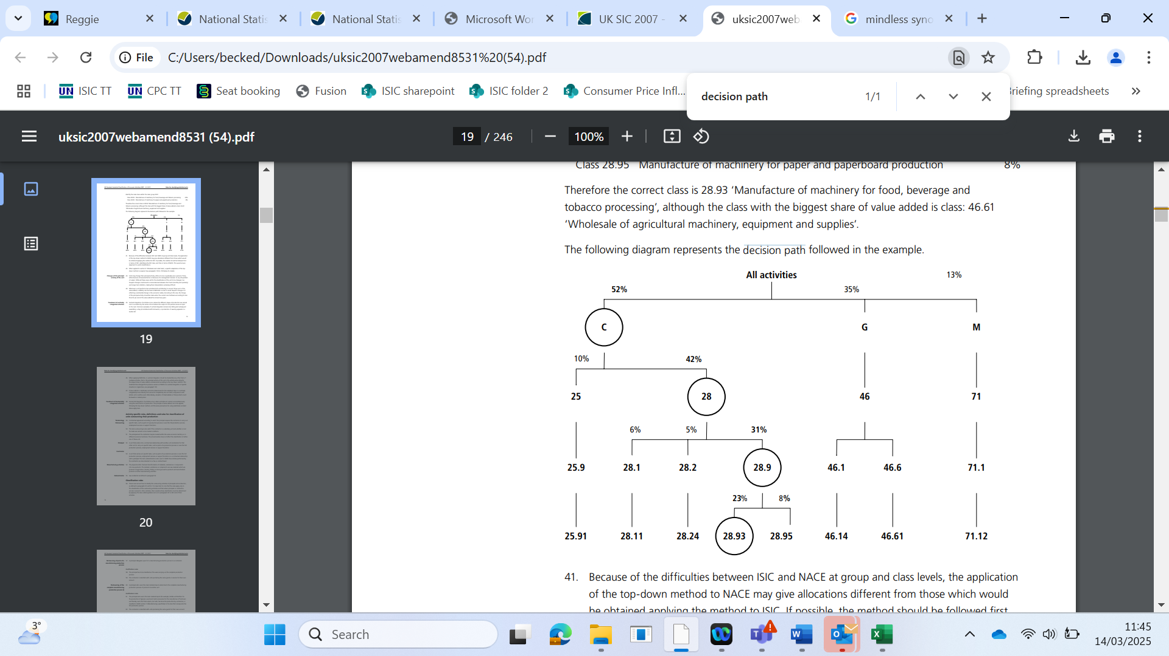

Many statistical units will carry out a limited number of economic activities, and their classification would be unaffected by the structure of the classification framework. However, other units split their production across an array of different subclasses, which can lead to different classification outcomes with different classification framework structures.

To further explain how this may be split, we will use the example of a unit that carries out the following retail activities (where the number beside each category represents the percentage of value added from each):

New petrol cars (21%)

New green cars (18%)

New petrol lorries (2%)

New green lorries (5%)

Old petrol cars (20%)

Old green cars (16%)

Old petrol lorries (1%)

Old green lorries (17%)

**Option 1: Create subclasses under the NACE category**

One way would be to follow the previous practice, which was to create eight different five-digit subclasses under the one NACE class as follows:

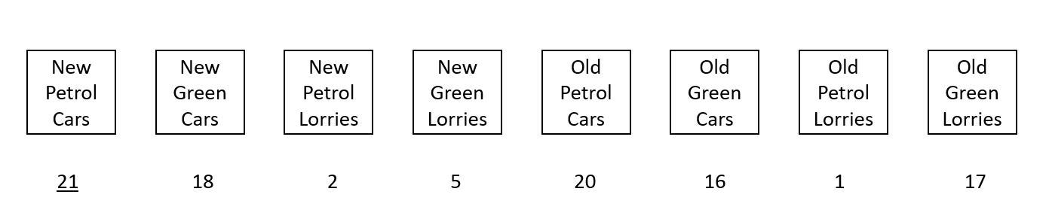

In the scenario above, the unit would be classified as a retailer of new petrol cars and all the output associated with the unit would be counted under this category.

While this may seem reasonable; the unit creates more value-added from old vehicles than it does from new vehicles and more from green vehicles than it does from petrol vehicles. Therefore, the structure of the classification framework appears to lead to a classification of the unit that doesn’t best represent the economic activities it engages in.

**Option 2: Create two subsets of the NACE class based on the new/old split**

Another way of engineering the split would be to create two SIC classes that are subsets of the NACE class (based on a split by age), with the five-digit subclasses based on the environmental category and the type category.

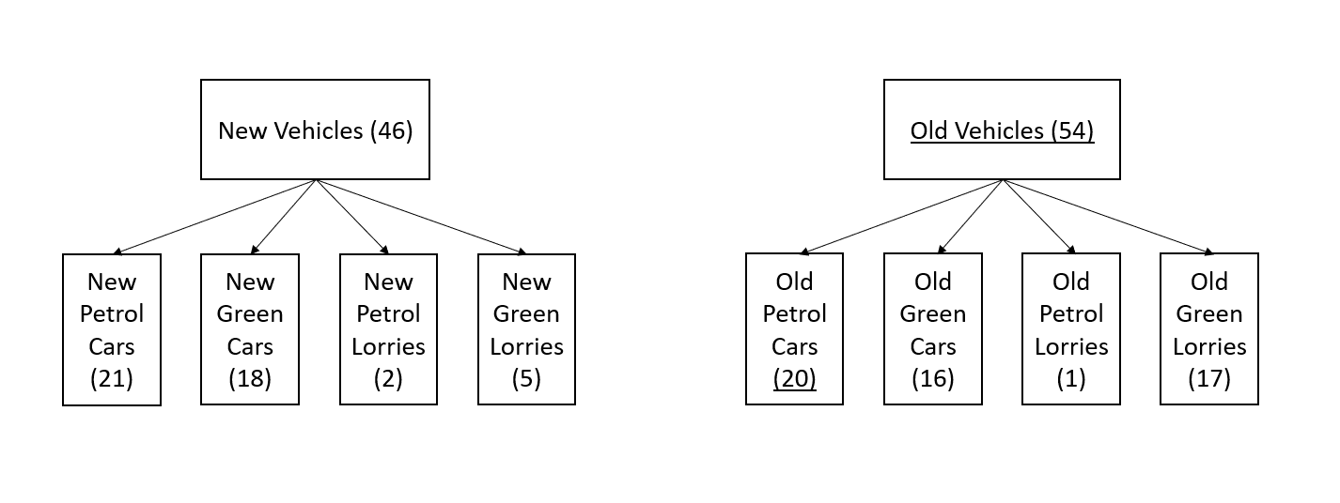

The unit would be classified as selling old petrol cars and the output would be more appropriately allocated in terms of the new/old split. However, while the unit creates more value-added in terms of green vehicles, this framework would lead to all of its output being considered to be in relation to petrol vehicles.

Therefore, this framework would provide more accurate statistics in terms of the old/new split but less accurate statistics in terms of the petrol/green split.

**Option 3: Create two subsets of the NACE class based on the new/old split**

A further way of engineering the splits would be to create two subsets of the NACE class based on the petrol/green split rather than the new/old split.

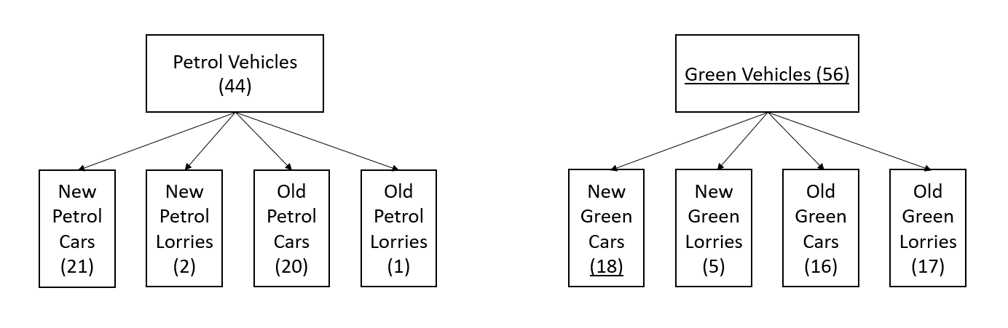

Now the unit would be classified as selling new green cars, rather than old petrol cars or new petrol cars, and the output would be allocated more accurately in terms of the environmental split.

However, it wouldn’t be allocated ‘correctly’ in terms of the age split because the sub-category of green vehicles with the highest value-added is new green cars, even though the unit as a whole creates more value-added from old categories.

## The structure of the new SIC classification framework

This example illustrates the importance of the framework’s structure, because the splits made higher up the chain have a more consequential effect on the classification of a unit than those further down the chain.

It also means that means that simply creating many more sub-classes removes any process of prioritisation. This also results in a higher probability that the classification process causes a category being selected that is not representative of any of the splits. This is illustrated in the example above, when no prioritisation took place where the unit creates more value-added from selling old vehicles and from green vehicles but was still classified to new petrol cars.

As such, a process of prioritisation needs to take place to determine which split takes precedence over the others. In this example, there is no ‘correct’ classification as such, but a choice needs to be made to make one of the splits more important than others in terms of the accuracy of the statistics being produced against that split.



© Crown copyright 2019

This publication is licensed under the terms of the Open Government Licence v3.0 except where otherwise stated. To view this licence, visit nationalarchives.gov.uk/doc/open-government-licence/version/3 or write to the Information Policy Team, The National Archives, Kew, London TW9 4DU, or email: [psi@nationalarchives.gsi.gov.uk](mailto:psi@nationalarchives.gsi.gov.uk).

Where we have identified any third-party copyright information you will need to obtain permission from the copyright holders concerned.