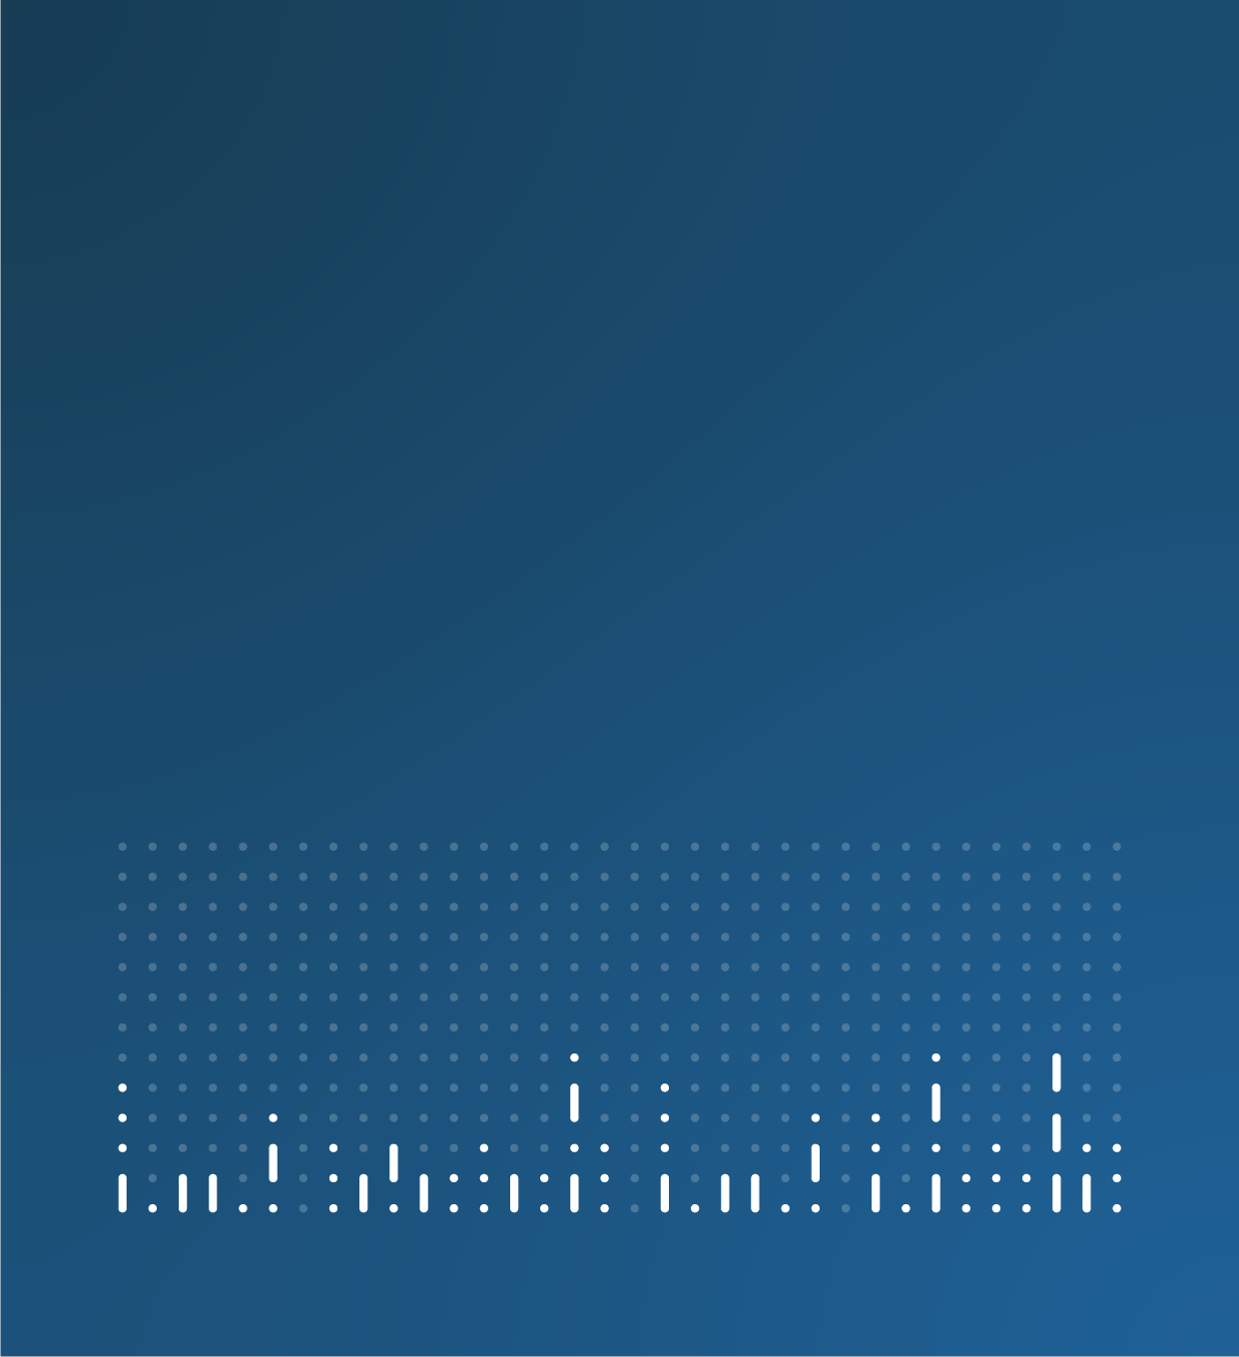

User requirements for official suicide statistics

Opens: 24 April 2025

Closes: 18 June 2025

Office for National Statistics



Contents

Overview 2

Why your views matter 4

Questions 5

Proposed options 5

About you 8

# Overview

The Office for National Statistics (ONS) is exploring ways to improve our [annual suicide statistics](https://www.ons.gov.uk/peoplepopulationandcommunity/birthsdeathsandmarriages/deaths/bulletins/suicidesintheunitedkingdom/2023) to ensure clarity for all our users.

Below, we summarise the context around the need for improvement and propose three options. When responding to the questionnaire, please provide your favoured option with a justification detailing how this would meet your needs. The details of these options are also in the user questionnaire.

In England and Wales, all deaths by suicide are certified by a coroner and cannot be registered until an inquest is complete. This results in a delay between the date the suicide occurred and the date it is registered and received by the ONS. Currently, ONS suicide releases are published on a registration basis, that is the year in which the suicide was registered, and occurrence data is published in a [separate dataset](https://www.ons.gov.uk/peoplepopulationandcommunity/birthsdeathsandmarriages/deaths/datasets/suicideinenglandandwales). Registration data relates to the previous year and the occurrence data has a lag of an additional year. For example, in August 2024 we published 2023 suicide registrations and 2022 suicide occurrences.

The below chart shows the percentage of suicides registered in a given year by the year in which the suicide occurred. This shows that due to lengthening registration delays, a smaller proportion of suicides registered in a given year are occurring within the same year. Only 39% of suicides registered in 2023 had a date of death that was also in 2023. This is substantially lower than in 2002 when 67% of suicides registered in 2002 also occurred in 2002.

Percentage of suicide registrations by year of occurrence, England and Wales, 2002 to 2023.

* Blue bars show suicides that occurred in the same year as the registration year
* Orange bars show suicides that occurred in the year before the registration year
* Green bars show suicides that occurred 2 or more years before the registration year

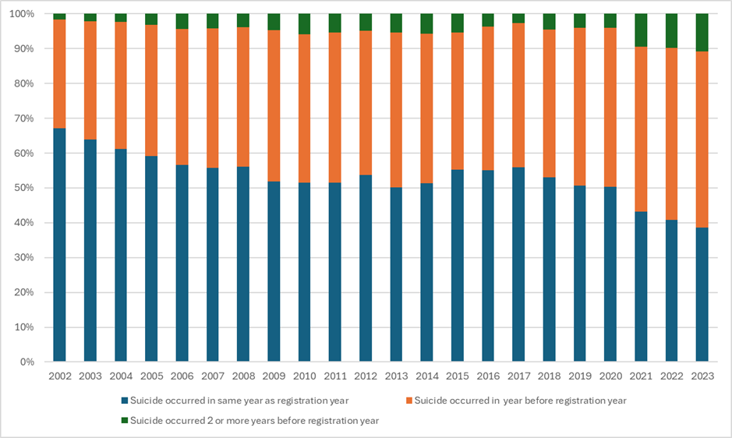

Due to this increase in registration delays, the ONS is considering how best to present suicide registration and occurrence data in our annual suicides release.

**Options for proposal:**

**Option 1**

Continue to publish the annual suicides statistics with all the commentary related to suicides registration data and occurrence data only appearing in a separate dataset, but with clearer commentary on the impact registration delays have on the annual figures. More signposting to the near to real-time suspected suicide surveillance (nRTSSS) data for [England](https://www.gov.uk/government/statistics/near-to-real-time-suspected-suicide-surveillance-nrtsss-for-england) and [Wales](https://www.gov.uk/government/statistics/near-to-real-time-suspected-suicide-surveillance-nrtsss-for-england) could also be provided.

**Option 2**

Continue to focus the annual suicides statistics on registration data but also include commentary on the most recent occurrence data received. This would provide a more complete picture of trends in suicides, but switching between registrations and occurrences could be confusing for users. We will consider the best way to present the registration and occurrence data to reduce confusion.

**Option 3**   
Instead of the current approach of providing the registration data only in our annual bulletin, the bulletin would be based on the occurrence data only. This would be more intuitive for users as it would give them annual figures for suicides that occur in a given year. However, due to the registration delays, there would be a longer time lag of approximately 18 months to two years to publish this data. For example, the release in August 2025 would provide suicide occurrence data for 2023, instead of registration data for 2024. In addition, the annual occurrence figures would never be complete and would have to be repeatedly revised as new registrations for suicides are received, making year-on-year comparisons more difficult.

With this option, we will also consider whether it is possible to adjust occurrence figures for suicides that have not yet been registered at a given point in time. This would enable more timely suicide occurrence figures to be produced.

### Why your views matter

Changing how we report our suicide statistics could affect the interpretability, timeliness, completeness and coherence of those statistics. We are seeking views from users of suicide statistics in, but not limited to, the following sectors, organisations and professions:

* Academia and researchers
* Central government departments
* Devolved nations
* Charity sector
* Coroners and courts conducting inquests
* Healthcare providers
* Local authorities and health and care boards
* Industries and employers with an interest in employee mental health
* Members of the public and support groups for affected communities
* Mental health organisations
* Universities and student unions
* Workplace wellbeing organisations

We want to hear your views so that we can consider what is best for our users. Your time completing this questionnaire would be greatly appreciated.

This user questionnaire is part of our wider plan to improve how we communicate all mortality statistics, and we will use feedback provided here to inform any changes to the communication of other ONS mortality related outputs, for example [ONS statistics on drug poisoning deaths](https://www.ons.gov.uk/peoplepopulationandcommunity/birthsdeathsandmarriages/deaths/bulletins/deathsrelatedtodrugpoisoninginenglandandwales/2023registrations).

### What happens after the questionnaire closes

Your answers will be stored confidentially by the ONS. They will be used to improve future annual suicide bulletins and potentially other mortality statistics. Individual responses will not be shared in full outside of the ONS, and names of individuals and organisations will not be linked to any feedback you provide.

We will publish an anonymised summary of the responses received, and will use your feedback to decide which of the three proposed options will be implemented. Each proposed option may have different timescales for when it can be delivered. We will provide further detail on timescales for the proposed option in the published summary. We may also undertake follow-up discussions with some users to help implement the proposed option.

If you have questions about this user survey, please email [health.data@ons.gov.uk](mailto:health.data@ons.gov.uk).

### If you need support

If you are struggling to cope, please call Samaritans for free on 116 123 (UK and the Republic of Ireland) or contact other sources of support, such as those listed on [the NHS Help for suicidal thoughts web page](https://eur03.safelinks.protection.outlook.com/?url=https%3A%2F%2Fwww.nhs.uk%2Fmental-health%2Ffeelings-symptoms-behaviours%2Fbehaviours%2Fhelp-for-suicidal-thoughts%2F&data=05%7C02%7CNicola.Fulton%40ons.gov.uk%7Cbfd2a283ee7f408a7e2308dd7dce83dc%7C078807bfce824688bce00d811684dc46%7C0%7C0%7C638805048100510627%7CUnknown%7CTWFpbGZsb3d8eyJFbXB0eU1hcGkiOnRydWUsIlYiOiIwLjAuMDAwMCIsIlAiOiJXaW4zMiIsIkFOIjoiTWFpbCIsIldUIjoyfQ%3D%3D%7C0%7C%7C%7C&sdata=INkoJwc%2FfHTPsMU61G09%2B5sirOid23Kp5K%2FBK1zNu00%3D&reserved=0). Support is available 24 hours a day, every day of the year, providing a safe place for you, whoever you are and however you are feeling.

# Questions

### Proposed options

**We are exploring three options for how we can improve our annual release and would like to get your feedback. Please select one option and write a brief explanation of how this option would best meet your needs**.

**Option 1**

Continue to publish the annual suicides statistics with all the commentary related to suicides registration data and occurrence data only appearing in a separate dataset, but with clearer commentary on the impact registration delays have on the annual figures. More signposting to the near to real-time suspected suicide surveillance (nRTSSS) data for [England](https://www.gov.uk/government/statistics/near-to-real-time-suspected-suicide-surveillance-nrtsss-for-england) and [Wales](https://www.gov.uk/government/statistics/near-to-real-time-suspected-suicide-surveillance-nrtsss-for-england) could also be provided.

**Option 2**

Continue to focus the annual suicides statistics on registration data but also include commentary on the most recent occurrence data received. This would provide a more complete picture of trends in suicides, but switching between registrations and occurrences could be confusing for users. We will consider the best way to present the registration and occurrence data to reduce confusion.

**Option 3**

Instead of the current approach of providing the registration data only in our annual bulletin, the bulletin would be based on the occurrence data only. This would be more intuitive for users as it would give them annual figures for suicides that occur in a given year. However, due to the registration delays, there would be a longer time lag of approximately 18 months to two years to publish this data. For example, the release in August 2025 would provide suicide occurrence data for 2023, instead of registration data for 2024. In addition, the annual occurrence figures would never be complete and would have to be repeatedly revised as new registrations for suicides are received, making year-on-year comparisons more difficult.

With this option, we will also consider whether it is possible to adjust occurrence figures for suicides that have not yet been registered at a given point in time. This would enable more timely suicide occurrence figures to be produced.

Longer-term, we are exploring alternative data sources which will provide more up-to-date occurrence data, but in the interim, we would appreciate your views on how we are presenting suicide registrations and occurrences in our annual bulletin.

**Further information**

The below table provides a summary of differences between registration data and occurrence data.

|  |  |
| --- | --- |
| **Registration data** | **Occurrence data** |
| Difficult interpretation: Users often interpret the data as occurrences | Easy interpretation: Occurrence data is more intuitive for users |
| More timely release: Released annually approximately eight months after all annual registrations are processed | Less timely release: Could be released annually, approximately18-24 months after annual occurrence data is processed. |
| Complete data: Data for previous years does not require revision | Incomplete data: Occurrence data would require annual revision as registrations are processed |
| Comparable to suicide statistics published by [National Records of Scotland (NRS)*](https://www.nrscotland.gov.uk/publications/probable-suicides-2023/) and the [Northern Ireland Statistics and Research Agency (NISRA)](https://www.nisra.gov.uk/news/northern-ireland-suicide-statistics-2023). | More comparable to suicide statistics published by Republic of Ireland who report occurrences for deaths of ‘suicide and intentional self-harm’ only, not for ‘events of undetermined intent’. |

* In Scotland the Procurator Fiscal registers deaths as probable suicides within eight days and National Records of Scotland report probable suicide statistics.

1. Which is your preferred option for improvements to the annual suicides release? (Required)
   * Option 1
   * Option 2
   * Option 3
2. Please provide a brief explanation of how this option best suits your needs. (Required)
3. Please provide any further feedback on how we present suicide registrations and occurrences in our annual suicides bulletin. (Optional)
4. Please provide any other feedback on how we can improve our annual suicides release. (Optional)

### About you

1. What is your name? (Optional)
2. What is your email address? (Optional)
3. If you are responding on behalf of an organisation, please tell us what sector or organisation you represent. (Optional)

* Academia and research
* Arm's length body and other public sector
* Business and industry with an interest in employee mental health
* Central Government and Devolved Nations
* Charity and voluntary organisation
* Coroners and courts conducting inquests
* Local Government
* Members of the public and support groups for affected communities
* Mental health organisations
* Think tank
* University or student union
* Workplace wellbeing organisations

1. What is the name of your organisation? (Optional)